**Snap Student Manual**

Education Unlimited, Summer 2017

Snap can be accessed at http://snap.berkeley.edu/snapsource/snap.html.

A free account will allow you to store projects in the cloud for access from any computer.

**Snap Map:** 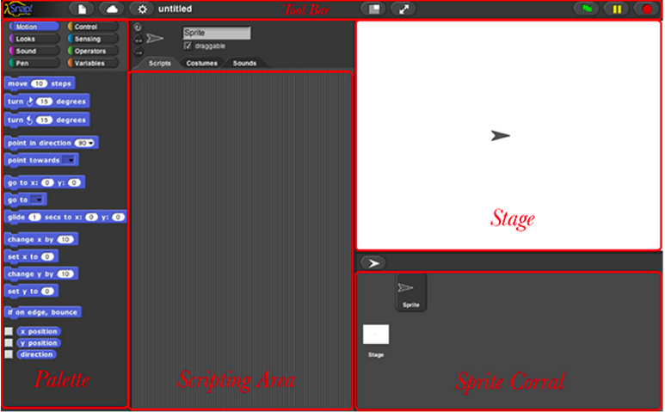

* + Palette: Contains all the blocks. Drag and drop them to the Scripting Area to make scripts. The Palette has 8 different categories.
  + Scripting Area: Where you create scripts
  + Stage: Where sprites perform the scripts
  + Tool Bar: Where you can log into your account (using the cloud shaped button) and save projects (using the paper shaped button)
  + Sprite Corral: Where you keep track of sprites

**Programming with Snap:**

* Programs consist of scrips, which are made up of blocks.
* Blocks come from the Palette, which is divided into 8 categories, which will be detailed below.
* Scripts are creating by dragging blocks from the Palette to the Scripting Area. Blocks snap together - just like the name of the language! Different shaped blocks have different meanings.
* Most blocks are brick-shaped. They are commands that the sprites can carry out, in order.



* The hat-shaped blocks (from the ‘Control’ section of the Palette) tell each script when the sprite should carry them out. They go at the top of each script.
  + One of the most common hat-shaped blocks is this one, which allows the program to start when the user clicks the green flag.



* The C-shaped and E-shaped blocks, also from ‘Control,’ can be wrapped around other blocks.
  + C-shaped blocks can be wrapped around one set of other blocks.

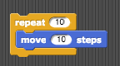

* + E-shaped blocks can be wrapped around 2 sets of other blocks.

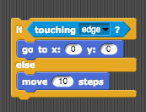

* To test or run scripts, click on them in the scripting area and the sprite will execute them on the stage. Each script is highlighted while it is running.

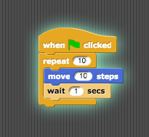

* Save projects by clicking the paper button in the tool bar and selecting “save as,” name it according to what it does, and save to the cloud for easy access from any computer. You can also use this section to open past projects that you’ve saved to the cloud.

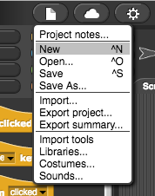

* To make a project “shareable,” so that people outside your account can see it, click the “Share” button in the save project page. Then, the URL for the project can be copied and given to others so they can see it.

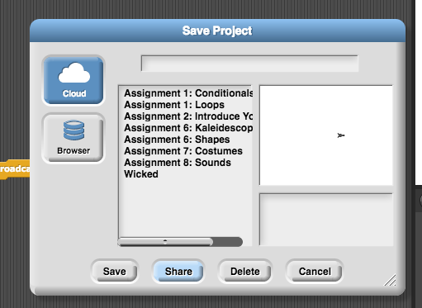

* To start a project, press the green flag button on the top right above the Stage. To pause, the yellow parallel lines. To stop the program completely, click the red stop sign.



* To debug projects, you can go through your scripts step by step by turning on the “Visible Stepping” setting from the settings menu in the toolbar:

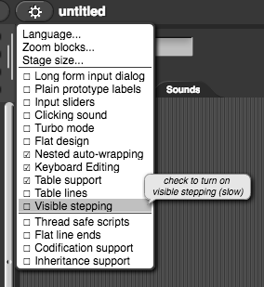

**Palette Organization**

* In the palette, blocks are organized by the types of things that they do.
  + Blocks in the ‘Motion’ section control the sprite’s motion, where and how fast they move
  + Blocks in the ‘Looks’ section control how the sprite looks, including costume changing and special effects. Costumes can be imported using the paper-shaped button from Snap’s library or your own files.
  + Blocks in the ‘Sounds’ section control what sounds the sprite makes. Sounds can be imported using the paper-shaped button from Snap’s library or your own files.
  + Blocks in the ‘Pen’ section control the sprite’s use as a pen to draw shapes or trace where it goes.
  + Blocks in the ‘Control’ section control when and if each script or block executes.
  + Blocks in the ‘Sensing’ section allow the sprite to collect information related to its own condition or location, other sprites, and the computer user.
  + Blocks in the ‘Operators’ section allow math operations, logic operations, and string and character manipulation.
  + Blocks in the ‘Variables’ block are for creating, changing, and tracking variables and lists.

**Sprites**

* Each sprite has its own scripts. To see the scripts for any sprite, click on it in the Sprite Corral and its scripts will appear in the Scripting Area
* To create a sprite, click the ‘New Sprite’ button between the Stage and the Sprite Corral.

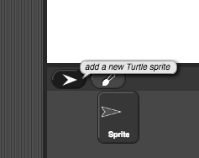

* Different sprites can do different things at the same time. For example, if both sprites have a script that runs when the green flag is clicked, both scripts will run when the user clicks the green flag.
* The background (“Stage”) can have its own scripts which can be accessed by clicking on it in the Sprite Corral.

**Broadcasting**

* Broadcasting is how sprites communicate with each other. One sprite can broadcast a message that will make one or more other sprites run a script. Broadcast messages are sent to all other sprites in the project.
* In any script, you can use the ‘broadcast’ or ‘broadcast and wait’ blocks from the ‘Control’ section of the Palette to send a message to the other sprites.



* If you click on the arrow in the space after the word broadcast, you can create a new message there, or select an existing message.
* The ‘broadcast and wait’ block causes the sprite that sends the message to wait until all sprites who have a ‘when I receive’ script for that message have finished their scripts.
  + For example, if Sprite 1 has this block in one of its scrips:



and Sprite 2 has a script with this hat block at the beginning:



Then Sprite 1 will wait until Sprite 2’s script finishes executing before it continues its script.

**Important definitions:**

**Algorithm**: A list of steps that you can follow to finish a task

**Program**: An algorithm that has been coded into something that can be run by a machine

**Loop:** The action of doing something over and over again. Snap blocks can be found in the palette, in the Control section and are pictured below.

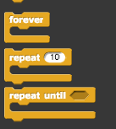

**Conditionals:** Statements that only run under certain conditions. Snap blocks can be found in the palette, in the Control section and are pictured below.

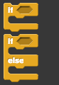

**Math Concepts in Snap**

Graphing: Points are in (x,y) form. The origin is at point (0,0). To graph a point, first find the x value on the x-axis, with positive numbers to the right and negative numbers to the left. Then, find the y value on the y-axis, with positive numbers up, and negative numbers down. Put a dot at the point where the 2 lines intersect.

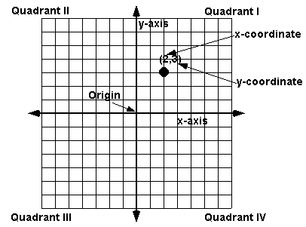

Snap blocks can be found in the palette, in the Motion section and are pictured below.

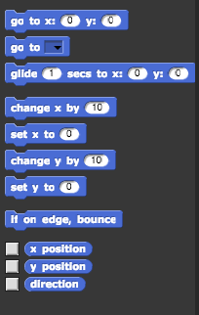

**Angles and Degrees:**

A degree, usually denoted by **°** , is a measurement of an angle, defined so that a full rotation is 360 degrees. Angles less than 90° are acute, angles equal to 90° are right angles, and angles greater than 90° are obtuse angles. A 180° angle is a straight line. A 360° angles goes all the way around a circle.

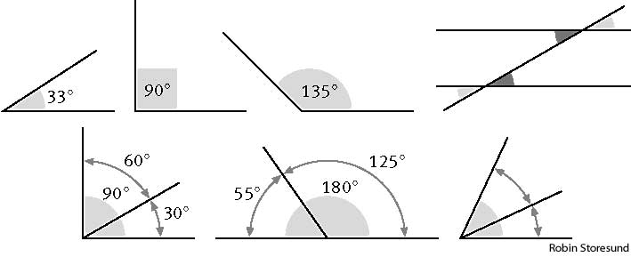

Snap blocks can be found in the palette, in the Motion section and are pictured below.

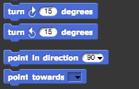

**Web Design via Google Sites**

Access and create sites via sites.google.com, free and easy to use from any browser.

Useful how-to links: <https://sites.google.com/site/educationunlimitedwebdesign/useful-links>

* The “Manage Site” section under settings (the circle tool button in the top right) is very important. There you can change
  + Background image and colors
  + Font, font size, and font color
  + Header and footer formats
  + Page format
  + Page order and hierarchy
  + Many other settings
* To add a new page, click the Create Page button(to the right of the edit button, with a page and a pluse sign)
* To edit any page, navigate to that page and then click the Edit button(the button with a pen on it in the top right). The strip across the top is all the text editing tools. Along the top of that section are the following categories:
  + Insert: insert images, links, text boxes, Google gadgets, etc.
  + Format: manipulate text, changing its style, alignment, etc
  + Table: create, edit, and delete tables
  + Layout: select the layout of the page
  + Help: search for topics to help develop the site